Name: Aliyu Abdulmalik

Admission number: 1510204003

Course: csc 404

**Speech synthesis as good design and abacus as bad design**

1. **Speech synthesis**: is the artificial production of human [speech](https://en.wikipedia.org/wiki/Speech). A computer system used for this purpose is called a speech computer or speech synthesizer, and can be implemented in [software](https://en.wikipedia.org/wiki/Software) or [hardware](https://en.wikipedia.org/wiki/Computer_hardware) products. A text-to-speech (TTS) system converts normal language text into speech; other systems render [symbolic linguistic representations](https://en.wikipedia.org/wiki/Symbolic_linguistic_representation) like [phonetic transcriptions](https://en.wikipedia.org/wiki/Phonetic_transcription) into speech.

‘*Synthesized speech can be created by concatenating pieces of recorded speech that are stored in a* [*database*](https://en.wikipedia.org/wiki/Database)*. Systems differ in the size of the stored speech units; a system that stores* [*phones*](https://en.wikipedia.org/wiki/Phone_(phonetics)) *or* [*diphones*](https://en.wikipedia.org/wiki/Diphone) *provides the largest output range, but may lack clarity. For specific usage domains, the storage of entire words or sentences allows for high-quality output. Alternatively, a synthesizer can incorporate a model of the* [*vocal tract*](https://en.wikipedia.org/wiki/Vocal_tract) *and other human voice characteristics to create a completely "synthetic" voice output.’(Wikipedia).*

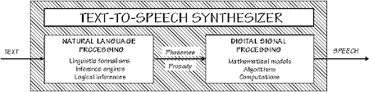

A text-to-speech system (or "engine") is composed of two parts: a [front-end](https://en.wikipedia.org/wiki/Input_method) and a [back-end](https://en.wikipedia.org/wiki/Front_and_back_ends). The front-end has two major tasks. First, it converts raw text containing symbols like numbers and abbreviations into the equivalent of written-out words. This process is often called text normalization, pre-processing, or [tokenization](https://en.wikipedia.org/wiki/Tokenization_(lexical_analysis)). The front-end then assigns [phonetic transcriptions](https://en.wikipedia.org/wiki/Phonetic_transcription) to each word, and divides and marks the text into [prosodic units](https://en.wikipedia.org/wiki/Prosody_(linguistics)), like [phrases](https://en.wikipedia.org/wiki/Phrase), [clauses](https://en.wikipedia.org/wiki/Clause), and [sentences](https://en.wikipedia.org/wiki/Sentence_(linguistics)). The process of assigning phonetic transcriptions to words is called text-to-phoneme or [grapheme](https://en.wikipedia.org/wiki/Grapheme)-to-phoneme conversion. Phonetic transcriptions and prosody information together make up the symbolic linguistic representation that is output by the front-end. The back-end—often referred to as the synthesizer—then converts the symbolic linguistic representation into sound. In certain systems, this part includes the computation of the target prosody (pitch contour, phoneme durations), which is then imposed on the output speech.

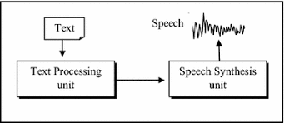

The first computer-based speech-synthesis systems originated in the late 1950s. Noriko Umeda et al. developed the first general English text-to-speech system in 1968 at the Electrotechnical Laboratory, Japan. In 1961 physicist [John Larry Kelly, Jr](https://en.wikipedia.org/wiki/John_Larry_Kelly,_Jr) and his colleague [Louis Gerstman](https://en.wikipedia.org/wiki/Louis_Gerstman) used an [IBM 704](https://en.wikipedia.org/wiki/IBM_704) computer to synthesize speech, an event among the most prominent in the history of [Bell Labs](https://en.wikipedia.org/wiki/Bell_Labs). Kelly's voice recorder synthesizer ([vocoder](https://en.wikipedia.org/wiki/Vocoder)) recreated the song "[Daisy Bell](https://en.wikipedia.org/wiki/Daisy_Bell)", with musical accompaniment from [Max Mathews](https://en.wikipedia.org/wiki/Max_Mathews). Coincidentally, [Arthur C. Clarke](https://en.wikipedia.org/wiki/Arthur_C._Clarke) was visiting his friend and colleague John Pierce at the Bell Labs Murray Hill facility. Clarke was so impressed by the demonstration that he used it in the climactic scene of his screenplay for his novel [2001: A Space Odyssey](https://en.wikipedia.org/wiki/2001:_A_Space_Odyssey_(novel)), where the [HAL 9000](https://en.wikipedia.org/wiki/HAL_9000) computer sings the same song as astronaut [Dave Bowman](https://en.wikipedia.org/wiki/David_Bowman_(Space_Odyssey)) puts it to sleep. Despite the success of purely electronic speech synthesis, research into mechanical speech-synthesizers continues.

1. **Abacus:** is a calculating tool that was in use in Europe, China and Russia, centuries before the adoption of the written [Hindu–Arabic numeral system](https://en.wikipedia.org/wiki/Hindu%E2%80%93Arabic_numeral_system)

*‘Abacuses come in different designs. Some designs, like the bead frame consisting of beads divided into tens, are used mainly to teach* [*arithmetic*](https://en.wikipedia.org/wiki/Arithmetic)*, although they remain popular in the* [*post-Soviet states*](https://en.wikipedia.org/wiki/Post-Soviet_states) *as a tool. Other designs, such as the Japanese* [*soroban*](https://en.wikipedia.org/wiki/Soroban)*, have been used for practical calculations even involving several digits. For any particular abacus design, there are usually numerous different methods to perform a certain type of calculation, which may include basic operations like addition and multiplication, or even more complex ones, such as calculating* [*square roots*](https://en.wikipedia.org/wiki/Square_root)*. Some of these methods may work with non-*[*natural*](https://en.wikipedia.org/wiki/Natural_number) *numbers (numbers such as 1.5 and ​3⁄4)’(wikipedia)*

The exact origin of the abacus is still unknown. Today, abacuses are often constructed as a [bamboo](https://en.wikipedia.org/wiki/Bamboo) frame with beads sliding on wires, but originally they were beans or stones moved in grooves in sand or on tablets of wood, stone, or metal.

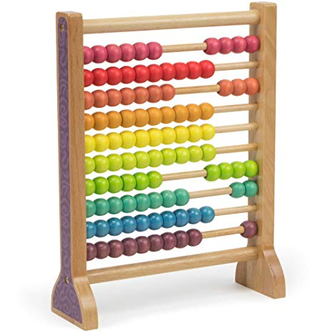

Although today many use [calculators](https://en.wikipedia.org/wiki/Calculator) and [computers](https://en.wikipedia.org/wiki/Computer) instead of abacuses to calculate, abacuses still remain in common use in some countries. Merchants, traders and clerks in some parts of [Eastern Europe](https://en.wikipedia.org/wiki/Eastern_Europe), [Russia](https://en.wikipedia.org/wiki/Russia), [China](https://en.wikipedia.org/wiki/China) and [Africa](https://en.wikipedia.org/wiki/Africa) use abacuses, and they are still used to teach arithmetic to children. Some people who are unable to use a calculator because of visual impairment may use an abacus. The use of the word *abacus* dates before 1387 AD, when a [Middle English](https://en.wikipedia.org/wiki/Middle_English) work borrowed the word from [Latin](https://en.wikipedia.org/wiki/Latin) to describe a sandboard abacus. The Latin word came from [Greek](https://en.wikipedia.org/wiki/Greek_language) which means something without base, and improperly, any piece of rectangular board or plank. Alternatively, without reference to ancient texts on etymology, it has been suggested that it means "a square tablet strewn with dust",[]](file:///C:\Users\Abdulazeez\Downloads\Abacus%20-%20Wikipedia.htm#cite_note-5)or "drawing-board covered with dust (for the use of mathematics)" (the exact shape of the Latin perhaps reflects the [genitive form](https://en.wikipedia.org/wiki/Genitive_case) of the Greek word, ἄβακoς *abakos*). Whereas the table strewn with dust definition is popular, there are those that do not place credence in this at all and in fact state that it is not proven. Greek ἄβαξ itself is probably a borrowing of a [Northwest Semitic](https://en.wikipedia.org/wiki/Northwest_Semitic), perhaps [Phoenician](https://en.wikipedia.org/wiki/Phoenician_language), word akin to [Hebrew](https://en.wikipedia.org/wiki/Hebrew_language) *ʾābāq* , "dust" (or in post-Biblical sense meaning "sand used as a writing surface").

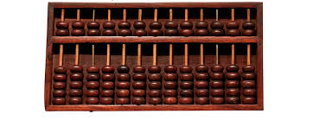

A tablet found on the Greek island [Salamis](https://en.wikipedia.org/wiki/Salamis_Island) in 1846 AD (the [Salamis Tablet](https://en.wikipedia.org/wiki/Salamis_Tablet)), dates back to 300 BC, making it the oldest counting board discovered so far. It is a slab of white marble 149 cm (59 in) long, 75 cm (30 in) wide, and 4.5 cm (2 in) thick, on which are 5 groups of markings. In the center of the tablet is a set of 5 parallel lines equally divided by a vertical line, capped with a semicircle at the intersection of the bottom-most horizontal line and the single vertical line. Below these lines is a wide space with a horizontal crack dividing it. Below this crack is another group of eleven parallel lines, again divided into two sections by a line perpendicular to them, but with the semicircle at the top of the intersection; the third, sixth and ninth of these lines are marked with a cross where they intersect with the vertical line.